NEWSLETTER: September 2025

Pictures of the Month

Senior

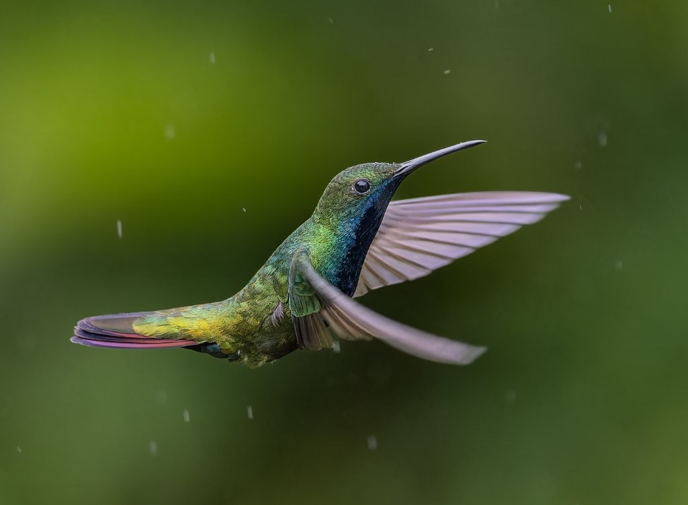

**BlackThroated Mango in the rain – Pieter Mare**

Junior

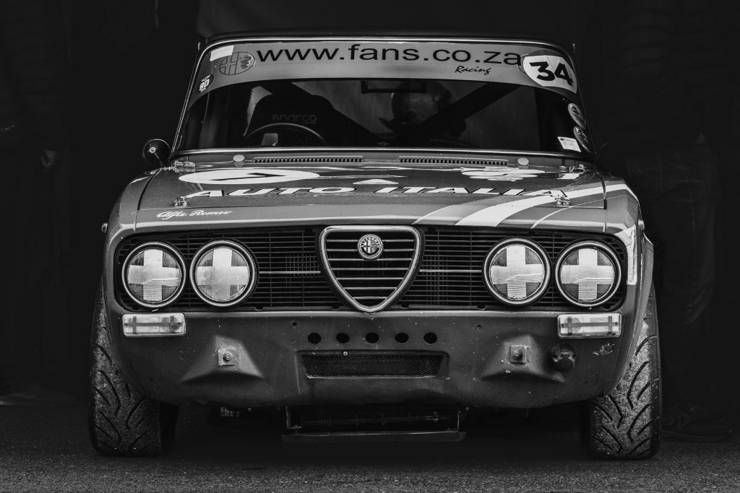

**Alfa Romeo - Terence Clarke**



Message from the Chair

**September 2025**

The standard of images submitted for the September club night was high, with some excellent photographs on display. Attendance continues to be of some concern with a number of regular members travelling. We expect a couple of members will be resigning this club year, although we have had two recent joiners.

I would request that even if members are going to be absent for the club meetings, it would be good if they could still submit images. These add to the overall learning and judging experience for the club.

**TOP system (The Other Project)**

We use the TOP system, linked to Photovault, as part of our judging process. It is fairly sensitive in the way it is set up for each session and can be a bit temperamental as we discovered at the Wednesday 17th meeting. We will review our procedures to avoid any repeats. There was a positive side though as the “live” judging process turned out to be a lot of fun.

Thanks to the judges, Eileen and club members for adapting to the circumstances so well.

**Judges**

The judging panels have previously been organised by Anne Hrabar, who after years of service has stepped down from the committee. Our thanks go to Anne for the excellent service she rendered as convener of judges. Peter Oosthuizen has assumed this role until the end of 2025.

Judging duties currently depend on a small number of senior members, assisted by external judges wherever possible. This is a call for more members to assist with judging.

One of the best ways to improve your photography is to judge and evaluate other people’s images. The senior judges will provide coaching for junior judges so that they are not dropped cold into the role.

**KPS committee**

The new committee is officially up and running. Laura Campbell has assumed the secretarial duties and may be tasked with other ad hoc tasks. Thorsten Siwitza has assumed the role of outings organizer.

As with the judges, we are always keen to get members to sign up to the committee. If there are members who feel that they may want to contribute to the effective running of the club, please contact the committee.

Alan King

Salon Acceptances

September 2025

**EDENVALE SALON**

Cathy 3

Anne 2

Carol 4 includes Category Runner up Medal

Alan 4 includes1 COM

Claudette 6

Pieter 9 includes 3 COM

**NATIONAL PHOTO 30TH BIRTHDAY SALON**

Carol 2

Anne 3 includes 1 COM

Claudette 2

Alan 4 includes 1 COM

Pieter M. 10 includes 1 COM

**9TH DANUBE CIRCUIT SALON**

Alan 22 acceptances include 1 Honourable Mention

**PSSA 28TH UP & COMING SALON**

Terence 2 COMs

Laura 1

# *Outstanding Achievement*

Well done Carol Phillips who was the [PSSA Website Competition Winner August 2025](https://pssa.co.za/website-competition-winners-aug-2025/)



Carol gave away all her secrets (well, not all 😊) in her presentation on “Table Top Photography “ at the September Interactive meeting.

The presentation is available and “Table Top” is the theme for the October Interactive meeting.

Entries via Photovault.

# ***October Presentation***

***East African Safari***

Graham and Gill Maskell visited Serengeti, Ngorongoro and Lomu island last year and Graham will be screening part one of his movie of the trip.

Having seen an early edit, I have no hesitation in recommending it.

Naming Images

It is important to be careful when naming images, particularly for any PSSA associated work , but also for club submissions where we follow PSSA conventions.

The rules are

* Each image must have a unique name; the name of the image may **not** be altered as acceptance records are based on the image name.
* Titles such as “Untitled” and “No Title” are not acceptable, nor are titles consisting solely of camera filenames or numbers.
* Sanctions will be imposed if an accepted image or print is re-titled, or if different titles are used for Colour and Monochrome versions or Print and Projected Digital Image versions of the same image.

Inadvertently renaming an image or using the same name is easy to do and often follows from trying an image with a different profile – Please be careful 😊

**October Meeting**

**Judges**

The October judges will be Gill Maskell, Cathy Birkett and Alan King

Club Calendar – 2025

Please refer to our website <https://www.knysnaphotosoc.com/calendar>

National Salons

**Information regarding salons is available at**

**https://pssa.co.za/category/salons/calendar-results-for-year-ending-July-2025/**