NEWSLETTER: August 2025

Pictures of the Month

Senior

**Mrs Mantis – Cathy Birkett**

Junior

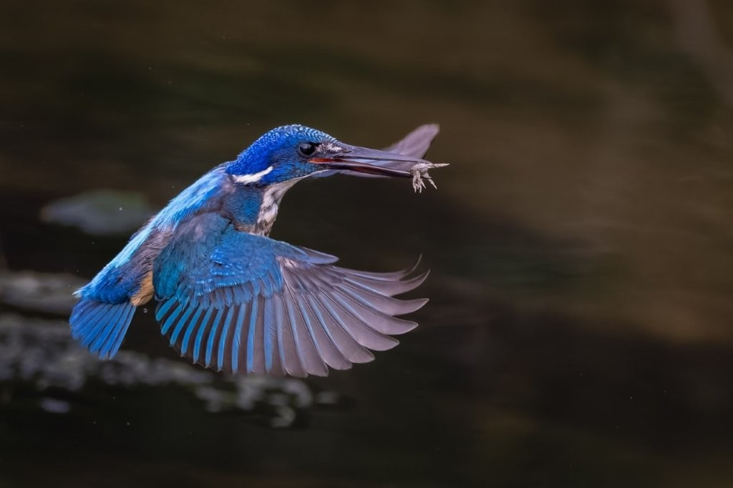

**Half collared fly by - Terence Clarke**



Message from the Chair

**August 2025**

The annual prizegiving was held at the club night on 21 August, based on the results achieved during the club year July 2024 – June 2025. The attendance was slightly disappointing, with several regular attendees either travelling or feeling unwell. Despite this, members enjoyed a good social event.

Club membership remains steady at 43 members.

**PSSA Congress at Struisbaai**

The PSSA congress was concluded at Struisbaai from 11-15 August. Peter Oosthuizen will publish a separate report on proceedings. Two themes emerged at the congress: the first and most important being that we should take photographs for “ourselves” and the second the need to grow participation of members in the PSSA.

**Tutorials and learning material**

Peter Oosthuizen continues to manage this portfolio and has provided links to many valuable sites dealing with various aspects of photography and post processing. ANY suggestions regarding content, themes and topics are welcome and should be communicated to Peter directly, or to any committee member.

**Interclub collaboration**

With the appointment of Alan King as the regional PSSA director for the Garden Route, there is an opportunity to increase the collaboration between Garden Route clubs.

**PSSA Guidelines**

KPS is aligned with the photographic guidelines adhered to by PSSA. Our photographic categories, guidelines and procedures conform to PSSA requirements. This is important if members participate in Salons and Competitions run by PSSA or indeed by international organisations which follow the same rules.

Alan King

Alan King was awarded the Brian Mullin Award. This award is presented to anyone who has made a significant contribution to the club, in any avenue of service. Alan was the overwhelming nominee and this comment from a member sums it up –

“From the moment Alan joined KPS, he became involved in all club matters. His positive attitude in embracing all things KPS has been exemplary. His recent election by PSSA as Regional Director, as well as the introduction of the Garden Route Salon is testimony to his aim of promoting all  Garden Route clubs. For KPS specifically, the introduction of the presentations as a review of images on club night is a great bonus, especially for those members who cannot attend.

Well done Alan

Salon Acceptances

August 2025

**EURASIA INTERNATIONAL RESULTS**

Alan 3

Eileen 16

Anne 17 includes 1 APE E-Certificate - Russia

Carol 25 includes 1 APE Honourable mention - China

**WITZENBERG SALON**

CAROL 1-Category Runner Up Silver Club Medal

Claudette 2

Kim 2

Alan 3

Willie 3

Doug 4

Pieter M. 9 includes 1 COM

**9th DANUBE INTERNATIONAL SALON**

Alan 22 includes 1 honourable mention

ALAN HAS ACHIEVED HIS DPSSA IN COLOUR

DPSSA is gained by accumulating 125 Salon acceptances in total.

PSSA SENIOR PICTURE OF THE MONTH JULY 2025

Claudette came 4th shared with14 photographers out of 48 entries

# 

# **PSSA Congress Struisbaai**

This year the PSSA Congress, hosted by The Cape Town Photographic Society, was held in Struisbaai, a small town in the Overberg. Struisbaai by is a small fishing village adjoining Cape Agulhas at the southern tip of Africa.

There are many Photographic opportunities in the area including:

1. The wreck of Keisho Maru
2. The lighthouse at Cape Agulhas
3. The Moravian Mission village at Elim
4. The Fishing village at Kassiesbaai
5. The fishing harbour and beach
6. Arniston and the cauldron
7. Canola fields
8. Opportunities to photograph blue cranes

The congress was well organised and every morning at 09H00 coffee and rusks were provided. There was a coffee break halfway through the morning session. A group of ladies gave us lunch and supper and the food, though simple, was tasty.

Well done to CTPS for catering to about 250 delegates from all over the country.

Early mornings were set aside for independent shooting while formal outings were arranged for the afternoons. These included guided walks through Kassiesbaai and Elim and a portrait session where some of the local people sat as models.

Delegates also received free entry to the Bredasdorp Shipwreck Museum which has many artifacts salvaged from some of the 173 vessels wrecked on and around Cape Agulhas. These range from early Portuguese and Dutch vessels to famous ships such as the Birkenhead which gave rise to the Birkenhead drill of “Women and children first”

Notable speakers in the morning sessions included :

1. Freeman Patterson, a Canadian who holds every possible Photographic honor in North America. His talk was all about taking pictures for yourself and realizing your own vision in photography. <https://www.freemanpatterson.com>
2. Kim Stevens will inspire us to take capture architectural images expertly.
3. Francois Roux, on the fallacies in club judging.
4. Phil Sturgess gave guidelines for capturing good sea photography.
5. Yvette Jordaan, on styling tips for food photography.
6. Martin Osner on thinking creatively when capturing landscapes.
7. Martin Barber, fresh from his Istanbul tours, spoke about travel photography with a purpose.
8. Laetitia Kenny gave tips on taking portrait photography to a new level.
9. Koot Marais gave an excellent presentation on wildlife photography.

Some of my pictures –

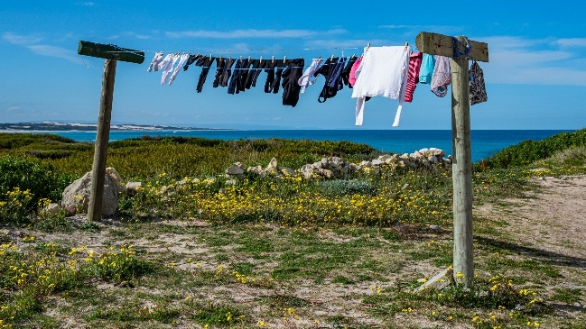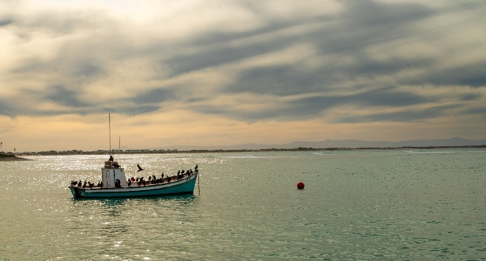

Overall, it was a worthwhile trip and I’d recommend that everyone should go at least once.

Peter Oosthuizen August 2025

**September Meeting**

**Judges**

The September judges will be Leoni Hattingh, Pieter Mare and Anton Legrange

Club Calendar – 2025

Please refer to our website <https://www.knysnaphotosoc.com/calendar>

National Salons

**Information regarding salons is available at**

**https://pssa.co.za/category/salons/calendar-results-for-year-ending-July-2025/**