

NEWSLETTER: July 2025
Pictures of the Month
Senior

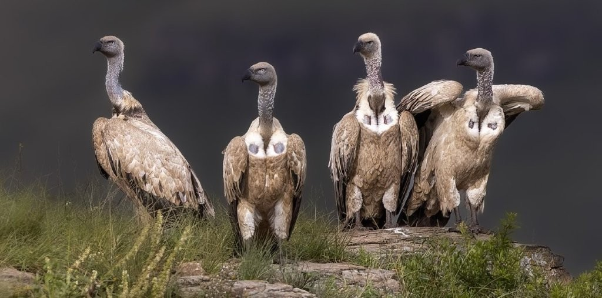

Giants Castle Gang – Claudette Gericke

Junior

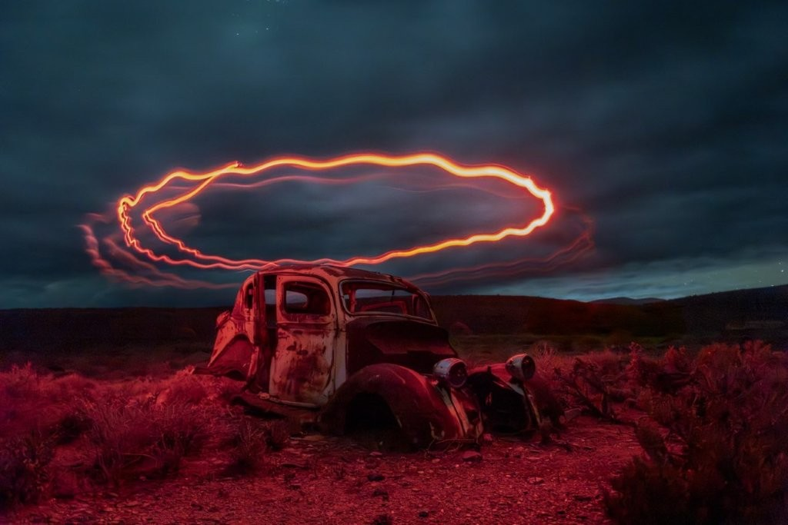

Old Rusty’s Halo – Terence Clarke

Message from the Chair
July 2025
AGM and Committee
The AGM was concluded at the club night on 16 July 2025. The Chairperson’s report, as well as the Financial report, were accepted as stated. The following members were elected to the committee for the year July 2025 to June 2026: Doug Emanuel, Peter Oosthuizen, Eileen Covarr, Laura Campbell, Thorsten Siwitza and Alan King. Chair expressed thanks to club members, outgoing committee members and incoming members. Minutes of the AGM will be available to members.
New member Dimitra (Dee) Hunter was welcomed to the club.
The annual awards will be hosted on 21 August 2025 at the Knysna Golf Club, once the final results from PSSA and International Salons are available. The venue and date were changed due to the clash with the PSSA National Congress and non-availability of the Oakhill venue on the 20th August.
PSSA Congress at Struisbaai
This is a reminder of the PSSA National Congress to be hosted in Struisbaai from 11-15 August, in the middle of the canola season and a very picturesque part of our coastline. Alan King will be attending in his role as recently appointed Regional Director for the Garden Route. The club expressed extreme gratitude to the outgoing director, Paul Rixom, for the sterling work he did during his tenure.
Tutorials and learning material
Peter Oosthuizen continues to manage this portfolio and has provided links to many valuable sites dealing with various aspects of photography and post processing. ANY suggestions regarding content, themes and topics are welcome and should be communicated to Peter directly, or to any committee member.
Interclub collaboration
A short presentation of 40 of the top images from the Interclub competition was shown after the AGM, with a good representation from KPS among them, including one of the winning Nature images by Pieter Mare. Pieter received his R500 voucher from Kloppers as a category winner. The images were representative of the generally very high quality of images submitted in the competition.
PSSA Guidelines
KPS is aligned with the photographic guidelines adhered to by PSSA. Our photographic categories, guidelines and procedures conform to PSSA requirements. This is important if members participate in Salons and Competitions run by PSSA or indeed by international organisations which follow the same rules.

Alan King , Chair

Salon Acceptances
July 2025

KRIEL FOTO CLUB 3RD DIGITAL SALON
Willie 1
Doug 2
Cathy 3
Alan 3 includes 1 COM

BALITO PHOTO CLUB 1st DIGITAL SALON
Sonia 1
Cathy 3
Willie 3
Alan 5 includes 2 COM

PSSA 27TH UP AND COMING SALON
Terence 1

TAF 14TH DIGITAL SALON
Alan 4
Cathy 8 includes 2 COM

August Meeting
Judges

The judges for August will be Pam Brighton, Peter Oosthuizen and Mark Preston White from Amber Camera Club

Club Calendar – 2025

Please refer to our website https://www.knysnaphotosoc.com/calendar

National Salons

Information regarding salons is available at
https://pssa.co.za/category/salons/calendar-results-for-year-ending-July-2025/

