

NEWSLETTER: October 2025
Pictures of the Month
Senior

Majestic Spitskoppe - Luana Laubscher

Junior

Turning Back – Laura Campbell

Message from the Chair
October 2025
The standard of images submitted for the October club night was again high, with some excellent photographs on display. We had one guest attending the evening.
Thank you to Graham Maskell for an excellent AV on the time he and Gill Maskell spent in East Africa on various game viewing events – it was a very well done and evocative of on of the joys of being in Africa – the wildlife and beautiful scenery.
TOP system (The Other Project)
Thank you to Eileen and Doug for a flawless running of the TOP system, as well as the other club night administrative presentations.
Judges
As mentioned last month, we continue to call for more members to assist with judging. One of the best ways to improve your photography is to judge and evaluate other people’s images. The senior judges will provide coaching for junior judges so that they are not dropped cold into the role.
KPS committee
Thorsten Siwitza as the coordinator for outings, is preparing a calendar for 2026 where we will link outings to specific themes, providing for better preparation ahead of outings, integration with the interactive zoom meetings and feedback from the outings. This is being done to increase the opportunity to learn from these outings, especially if they happen to lie outside of members’ main genres.
As with the judges, we are always keen to get members to sign up to the committee. If there are members who feel that they may want to contribute to the effective running of the club, please contact the committee.
End of calendar year
November will be the last meeting for 2025. Graham will show the second part of his AV at the next club night, and we will be presenting the results of the biannual competition. The theme for this competition is Light & Shadows. Members are allowed to submit three (3) images with the deadline for submission via Photovault being 1st November.
A suggestion has been made for an end of year social function to be held at Goukamma (Buffels). Date and time will be confirmed via WhatsApp chat group.
Alan King

Salon Acceptances
October 2025

9TH EXHIBITION DESIRE INTERNATIONAL 2025
Alan 7 acceptances including 1 DIPA Mention
DURBAN CAMERA CLUB
Peter O 1
Willie 2
Cathy 2
Claudette 3
Carol 6 includes 3 COM
Pieter M 6 includes 1 COM
Alan 7

TERRA AUSTRALIS INTERNATIONAL SALON
Anne 11
Salon Gold Medal for Lumo Skies


BLOEMFONTEIN CAMERA CLUB SALON
Cathy 1
Claudette 1
Willie 2
Peter O 2
Alan 4
Pieter M 7
PSSA Silver Medal Category winner Black Throated Mango in the Rain

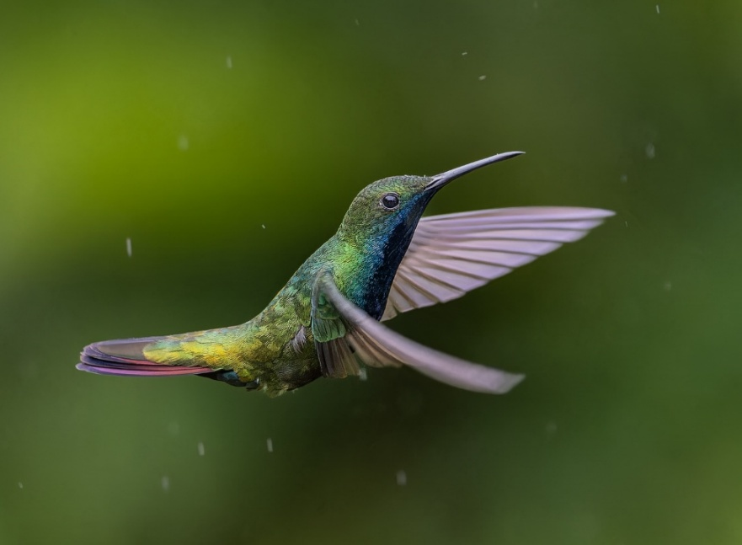

PSSA WEBSITE PICTURE OF
THE MONTH JULY 2025
Eileen came 7th out of 42 photographers

4 NATIONS INTERNATIONAL PHOTO CHALLENGE 2025
The following Images were chosen to represent PSSA



Carol Phillips Elegant lily bloom


Alan King Edge of lace

Eileen Covarr -Magical morning 1

Interactive meetings

October

Although the response to the set subject was disappointing there were some really good table top images and the discussion around the images was interesting and educational.

November Theme
The theme for November is my favourite genre and the reasons for it being the favaourite.

Example – Table top
Table top or still life photography stands out as a favourite genre for many photography enthusiasts and professionals. This genre, which involves arranging inanimate objects—often on a table or flat surface—and capturing them with careful composition, lighting, and perspective, offers a unique blend of creativity, technical challenge, and artistic expression.

Why Table Top/Still Life Is a Favourite Genre
- Creative Control
  - One of the primary reasons for favouring table top or still life photography is the immense creative control it provides. Still life allows the photographer to meticulously arrange every element within the frame. This precision helps bring the photographer’s vision to life exactly as imagined.
- Accessibility and Convenience
- Mastery of Technical Skills
  - Still life photography is an excellent way to hone technical skills. Lighting, composition, depth of field, and colour theory all play crucial roles.
- Telling Stories Through Objects
  - Every object chosen for a still life arrangement can carry symbolic meaning or evoke personal memories. This narrative quality adds depth and invites viewers to interpret the image in their own way.
- Timeless Artistic Tradition
  - Still life photography draws inspiration from the rich artistic tradition of still life painting, which dates back centuries.
- Personal Enjoyment and Satisfaction
  - Many photographers find personal satisfaction in the meditative process of arranging and photographing still life scenes. The genre encourages patience, observation, and attention to detail, making each session an opportunity for mindful creativity. The finished images often feel deeply personal and thoughtfully crafted.

November Presentation

East African Safari

After a first class AV of the Maskell’s visit to East Africa last year, Graham will be screening the second part of his movie at our November meeting.

November Meeting
Judges

The November judges will be Luana Laubscher, Thorsten Siwitsa and Peter Cavanagh, APSSA of the Midlens Camera Club in Mpumalanga.

Club Calendar – 2025

Please refer to our website https://www.knysnaphotosoc.com/calendar

National Salons

Information regarding salons is available at
https://pssa.co.za/category/salons/calendar-results-for-year-ending-July-2025/

